|  |
| --- |
| **Configure Veeam Backup & Replication** |

Requisites 1

Installation of the Veeam Package 1

Install available updates 5

Configure Veeam Backup & Replication 6

The 'veeam' menu 6

Step 1 – Configure Credentials 6

Step 2: Configure VCenter server 8

Step 3: configure the backup destination (configure synology). 9

STEP 4: Configure notifications 12

STEP 5: Configure backups without offsite backup 13

Preface 13

PROCEDURE 14

# Requisites

Veeam should be installed on a Windows 2012R2 VM with access to **Admin_Trust** and the **Backup** VLANs (IP: 172.16.2.18 & Mask: 255.255.255.128).

Sites:

When working in a jandenul.com integrated domain, a domain service account should be created with the name srv_backup_<ves/site>. Example: srv_backup_arp for Arpechim. This domain account should have rights to send emails from smtp.jandenul.com and should be local admin on windows servers at the site in question to allow VSS integrated backups.

When working at a site that is not jandenul.com integrated, follow guidelines for vessels.

Vessels:

Vessels are not jandenul.com integrated and have a local domain. In the local domain there should be a service account, srv_backup. This domain account should be local admin on windows servers on the vessel in question to allow VSS integrated backups.

Note: This manual is written for Veeam Backup & Replication 8.

# Installation of the Veeam Package

* Start the Veeam installer (usually this is done by mounting the Veeam iso in the VMware console from either a local iso or an iso stored in the datastore)
* Select Veeam Backup & Replication

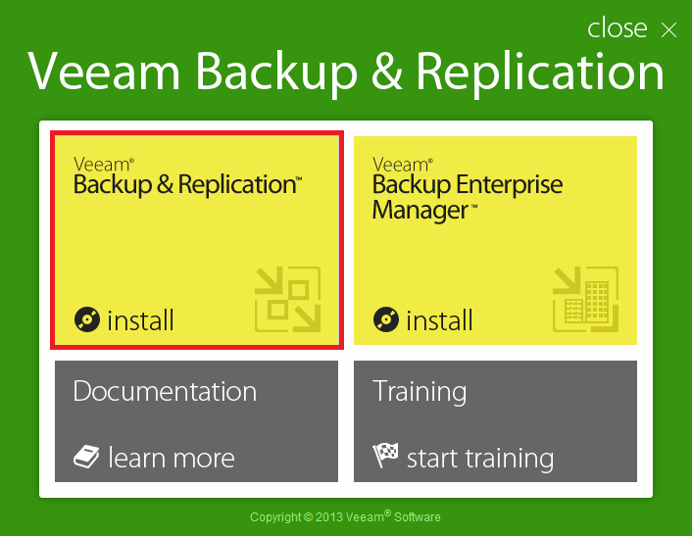

* Click Next

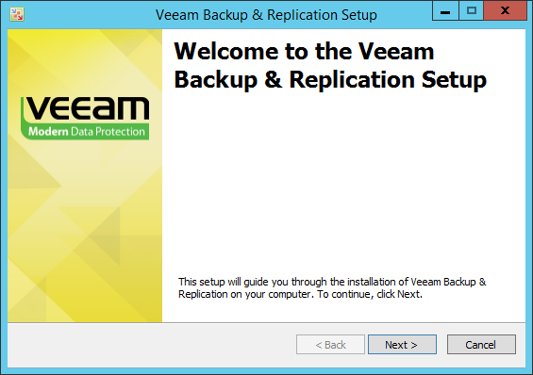

* Accept the license agreement

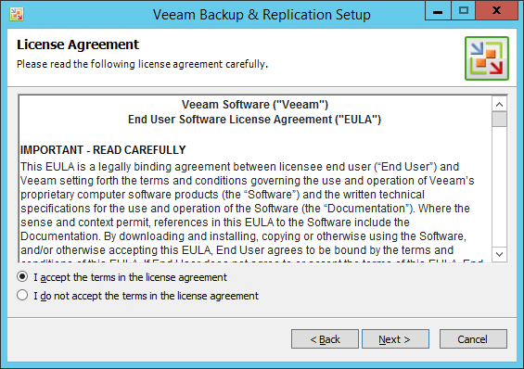

* Browse to the Veeam license file and click next (ignore 'not responding' messages)

You can find the license file here: \\Jdn-file01\ict_new_standard_sites_vessels\Licenses\Current\Backup

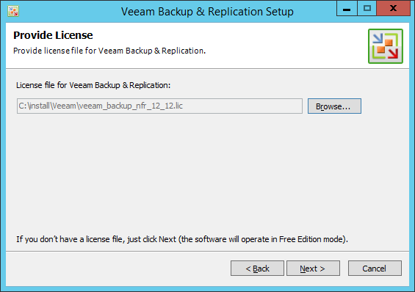

* Select ALL features **(including PowerShell!)** and click 'next'

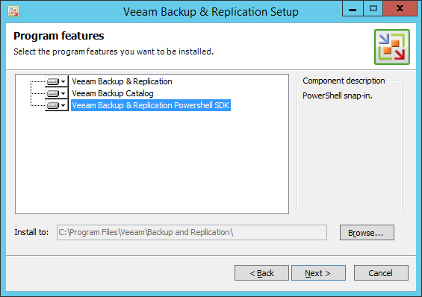

* Of course, your computer does not meet the minimum requirements, so click 'Install' and wait a minute or 2.

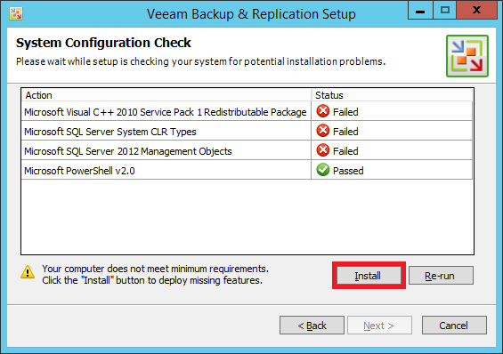

* Afterwards all requirements should be met, so click 'next'

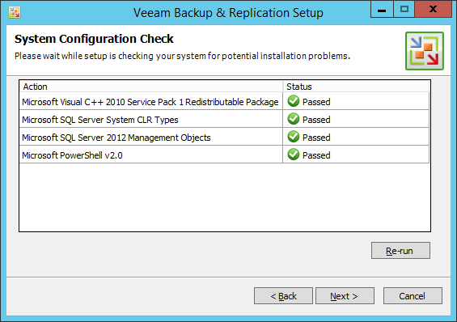

* At the Default Configuration overview screen, select "Let me specify different settings"

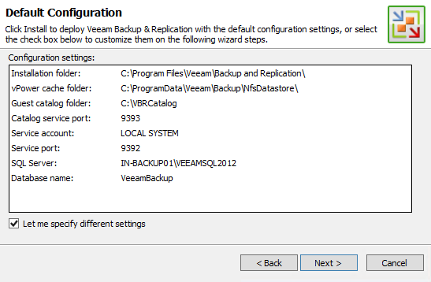

* Enter the service account credentials.
  + Username: <domain>\srv_backup (or srv_backup_xxx in case of JDN domain)
  + Password: the domain backup service account password

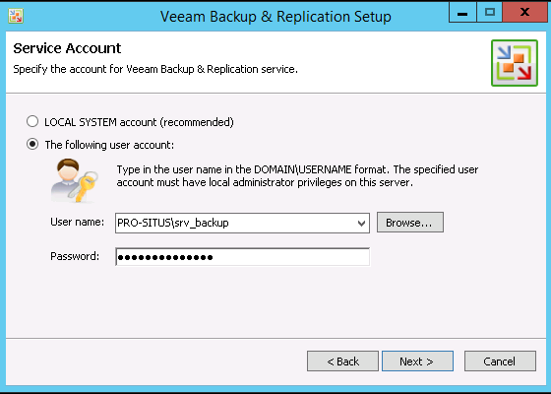

* After successful account validation, you must select 'install new instance of SQL server' & 'connect to the SQL server using Windows authentication of service account'. Click 'next'

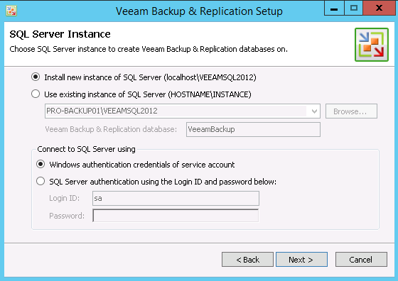

* On the 'port configuration' screen, leave the default ports of 9393 and 9392 and click 'next'

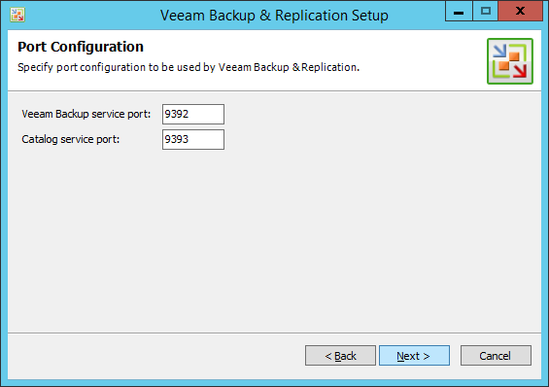

* On the 'Directory configuration' screen, leave the directories default and click 'next'

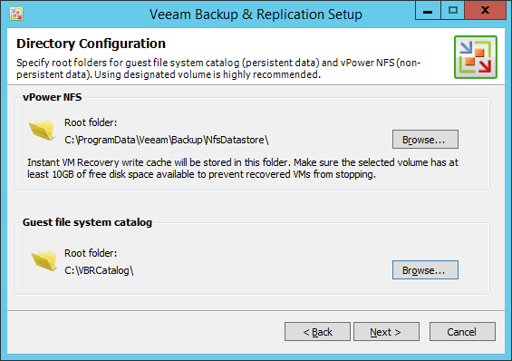

* On the 'Ready to install' screen, uncheck the 'Check for updates' checkbox and click 'Install'

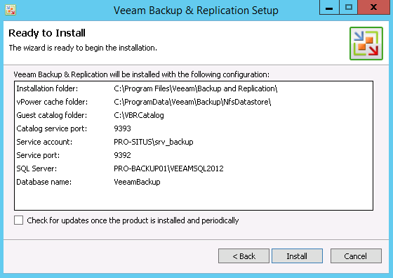

* And wait…

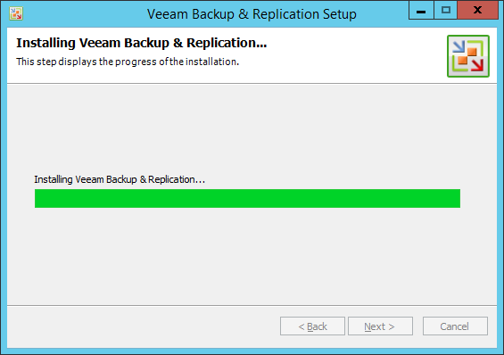

* And Finish… (either manually install the updates or let the installer take care of it)

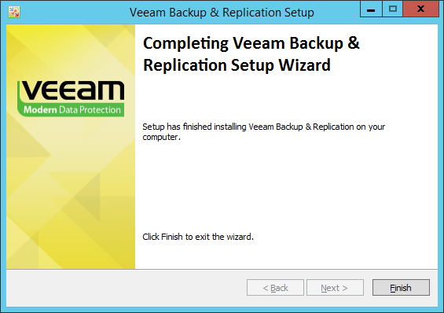

# Install available updates

Once the setup completes, run all the updates sequentially (if available). At time of this writing the available update is "3".

***NOTE***  
It is possible that update 2b gives an error it can't be installed. The workaround for this is to rename following file :   
*C:\Program Files\Common Files\Veeam\VeeamLicense.dll*

To:

*C:\Program Files\Common Files\Veeam\VeeamLicense_old.dll*

After this update 2b will install without problem and you can continue with update 3.

# Configure Veeam Backup & Replication

* Start Veeam to launch the initial wizard
* On the 'servers' screen you will be prompted to upgrade the local server, click next

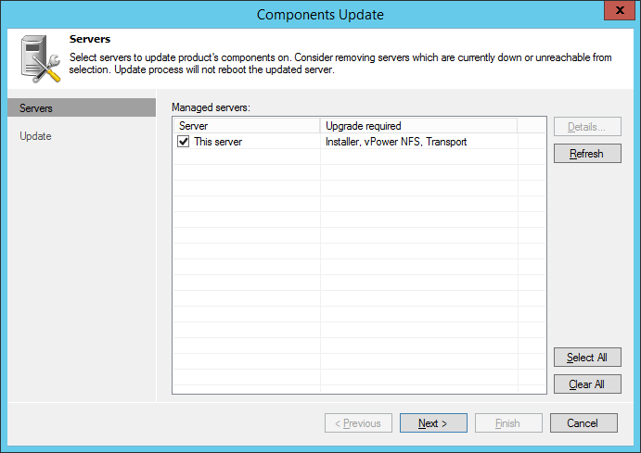

* And finish…

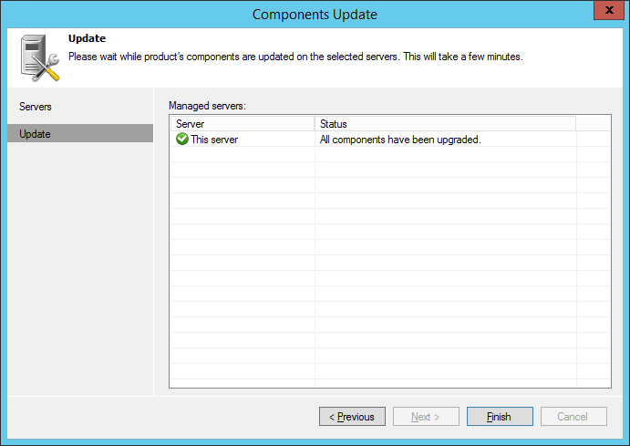

## The 'Veeam' menu

When this manual refers to the Veeam Menu, the system menu in the top left corner is meant.

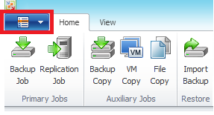

## Step 1 – Configure Credentials

First we will configure all the accounts needed for Veeam. These account are:

* The srv_backup ship domain service account or srv_backup_<ves> for jandenul.com integrated sites.
* The srv_backup Synology user account
* The srv_backup-account for vCenter
* Go to 'Veeam Menu' 🡪 Manage Credentials
* For each of the above credentials, add the required information

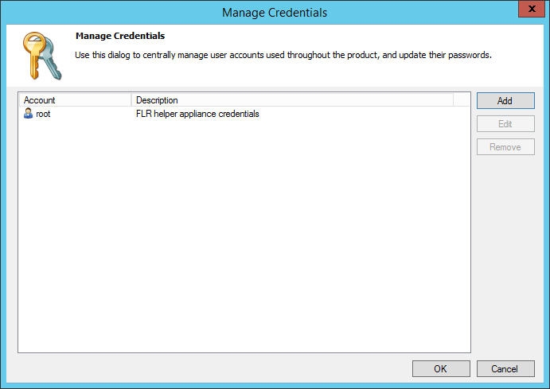

* + Click 'Add'
  + Enter the correct information. PLEASE SPECIFY DETAILED INFORMATION in the description box to avoid confusion between different srv_backup accounts!
  + Note:
    - All of the above accounts are saved as "windows" credentials. Actual domain accounts mention a domain, whereas the vCenter & Synology accounts do not.
    - When entering windows domain credentials, use <domain>\<username> syntax instead of <username>@<domain>, because the latter will cause errors when preparing the guest for backup: "Failed to prepare guest for hot backup. Details: Failed to check whether snapshot is in progress (network mode). RPC function call failed. Function name: [IsSnapshotInProgress]. RPC error:Access is denied. Code: 5"

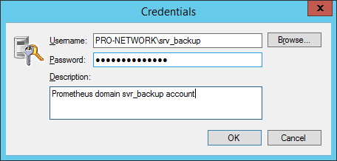

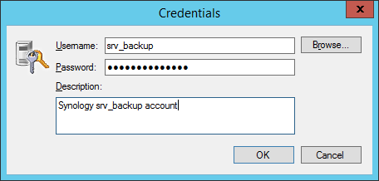

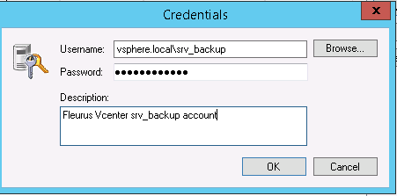

* After creation of all the accounts, close the Manage Credentials Window

## Step 2: Configure VCenter server

* Go to the add server wizard by selecting 'virtual Machines' 🡪 'VMware vCenter, right click and 'add server'

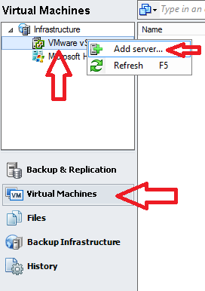

* Enter the vCenter IP and description and click next

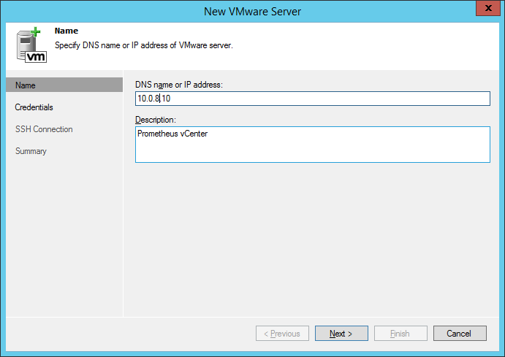

* For 'Credentials', select the vCenter account, leave the default port and click 'next'

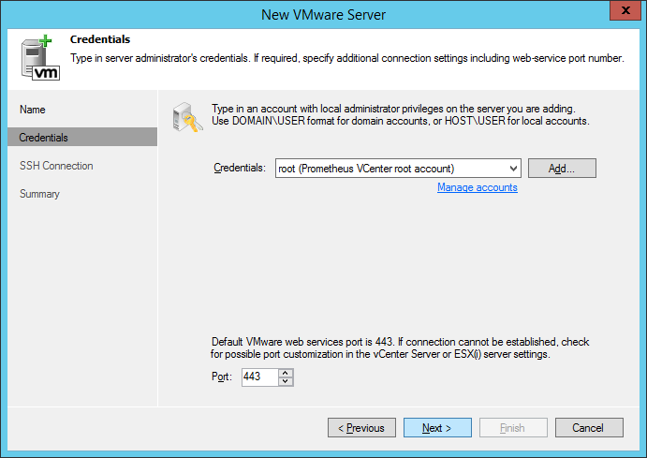

* If prompted for an unknown certificate, accept.
* Please wait for the configuration to finish…
* And 'Finish'. You should be able to 'see' the VMware infrastructure in the left pane…

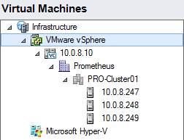

## Step 3: configure the backup destination (configure Synology).

* Go to 'backup infrastructure' 🡪 'Backup Repositories' 🡪 right click and 'Add Backup Repository'

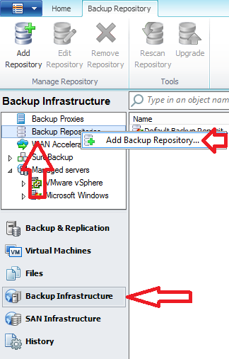

* Enter the repository name 'Synology Repository' and click next

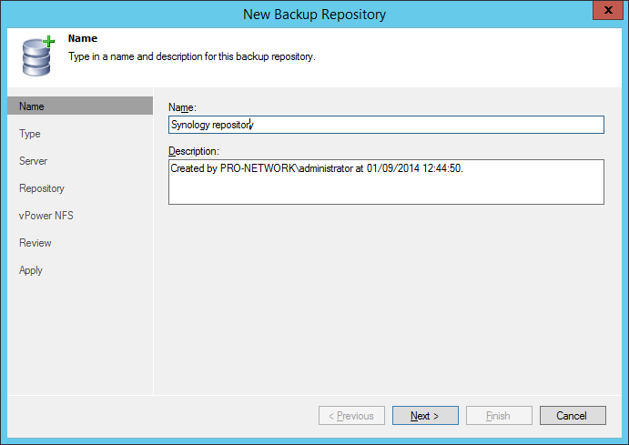

* In the 'Type' screen, select 'Shared Folder' and click next

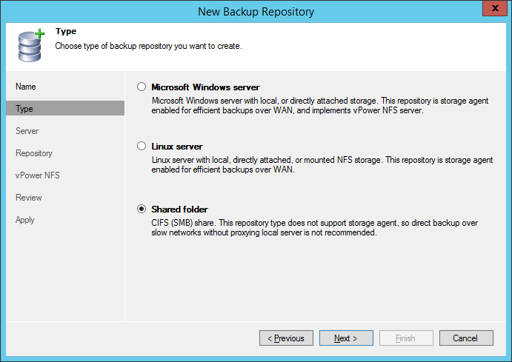

* Enter the correct information:
  + Shared Folder: \\172.16.2.10\veeam 🡪 BEWARE: MUST BE 172.16.2.10 ADDRESS (Backup network)
  + 'This share requires access credentials' must be checked
  + The Synology credentials must be selected
  + The proxy server: Use Automatic selection or 'This server'
  + Click Next

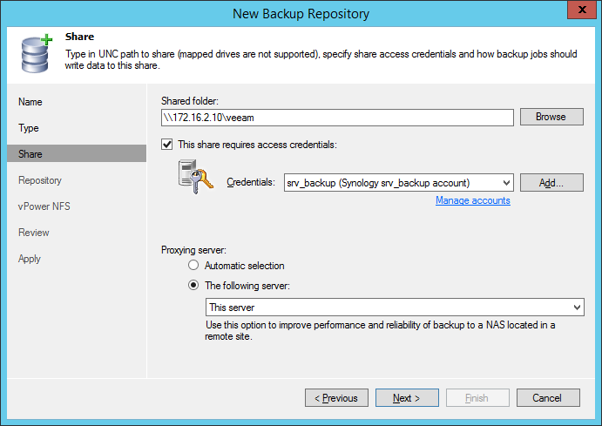

* In the 'Repository' screen:
  + click 'Populate' to verify space and connectivity.
  + Limit concurrent tasks to 4.
  + Click next

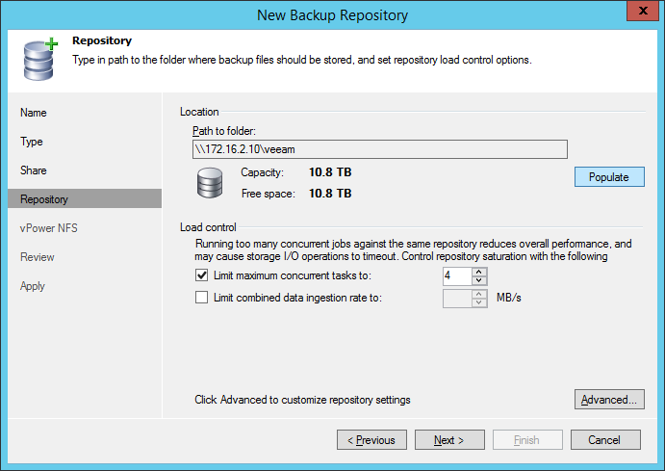

* In the vPower NFS windows leave everything default and click 'next'

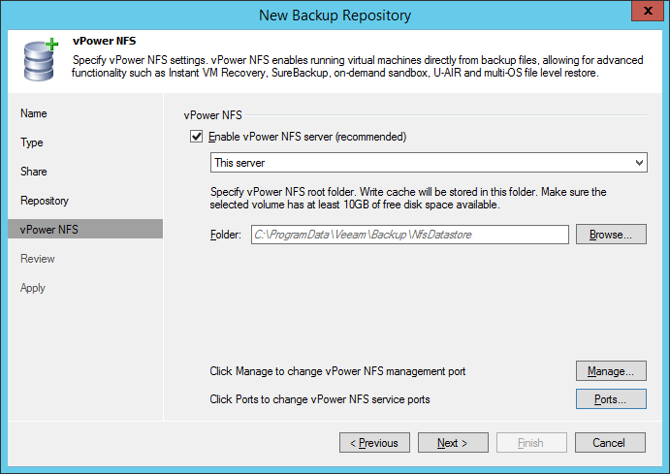

* In the 'review' window, click next

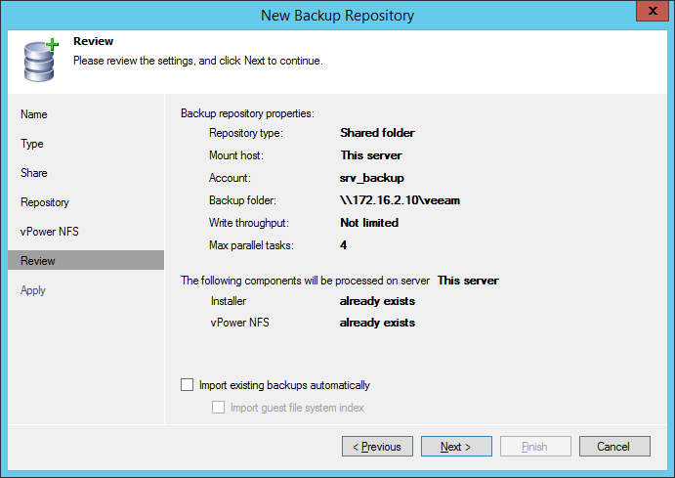

* Finally, click 'Finish'
* When VEEAM asks to change the location of the configuration, say 'no'.

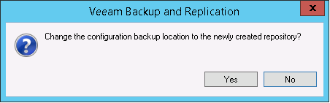

## STEP 4: Configure notifications

* Go to 'Veeam menu' 🡪 Options

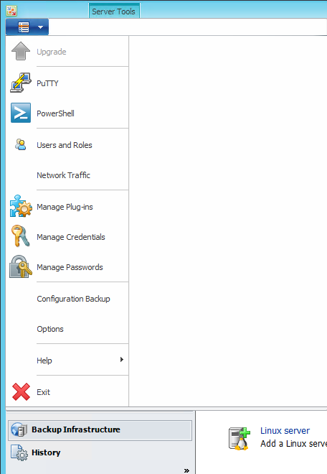

* Enable mail-notifications: **Ships**
  + SMTP Server: <ip of Commbox>
  + From: <VES>[.backup@<ves>.jandenul.com](mailto:.backup@%3cves%3e.jandenul.com)
  + To: [veeambackups@jandenul.com](mailto:veeambackups@jandenul.com)
  + Notify on success, warning and failure
* Enable mail-notifications: **Sites** (assuming Commbox is not present)
  + SMTP Server: smtp.jandenul.com (have the SA team allow the backup account to send mail, and enable authentication)
  + From: <VES>[.backup@jandenul.com](mailto:.backup@jandenul.com) (or srv_backup_<ves>@jandenul.com)
  + To: [veeambackups@jandenul.com](mailto:veeambackups@jandenul.com)
  + Notify on success, warning and failure

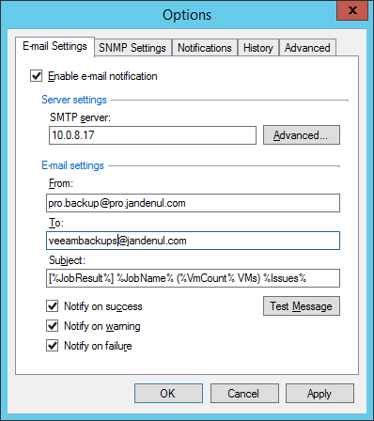

* Click 'Advanced' to enter the credentials for the SMTP server.
* Check 'This SMTP server requires authentication' and select the domain account for srv_backup you created earlier. Then click OK.

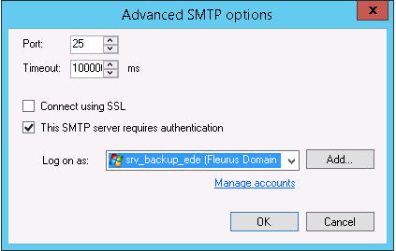

* Note: external mail sending credentials should be entered as [user@domain.tld](mailto:user@domain.tld) not as domain\user
* Click test message.   
  Verify if the message has arrived correctly in the mailbox. If not, check with SE if the user has been correctly created and has sufficient rights.
* Click ok

## STEP 5: Configure backups without offsite backup

### Preface

Backups must be configured, grouped by operating system for maximum deduplication. If vCenter Configuration is performed using the defined standards, virtual machines should be grouped by OS and type (Windows Servers, Linux Servers, Windows Clients and Templates/Others).

Every month, a full backup should be taken to ensure valid backups.

We will be creating 4 different jobs with the same settings. The following procedure has to be performed 4 times!

JOB NAMES:

* Backup Windows Servers
* Backup Linux Servers
* Backup Windows Clients
* Backup Others

JOB Schedule

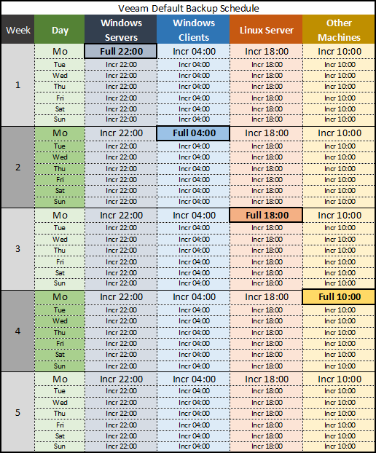

### PROCEDURE

* Go to 'Backup & Replication' and click 'Backup Job'

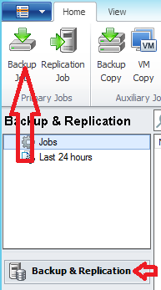

* Fill in the Job Name, modify the description to "[<VES>] <backup job name>" (example: [VGR] Backup Windows Clients) and click 'next'

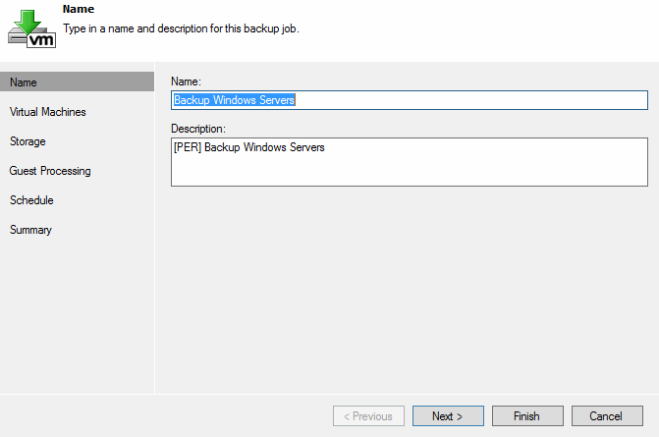

* In the next screen you need to define what group of machines you want to backup. If you select a group, any new machine created in the group will be automatically added to the backup!
* Click add to add a group of VM's

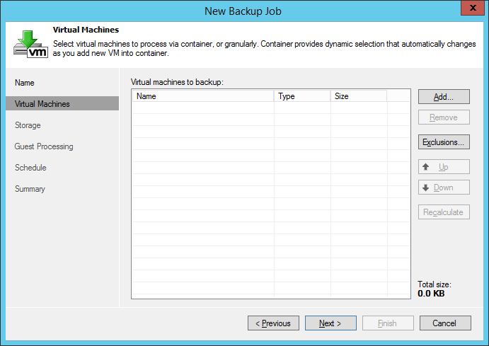

* In the 'Add objects', select 'VM's and templates' (third icon – see arrow)

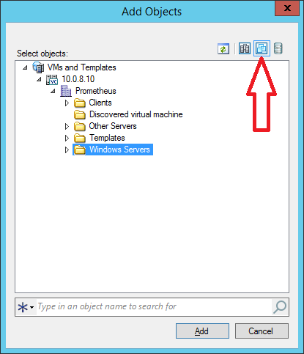

* Browse and select the group of servers you are scheduling a backup for (in the case: Windows Servers)
* Click 'Add'
* **When scheduling 'Windows servers' you NEED TO ADD AT LEAST ONE EXCLUSION. Exclude the backup server itself from backups, since this can cause deadlocks in very uncommon scenarios, but we would rather not risk this.   
  If the domain used in this setup is the jandenul.com domain, also exclude the DC from backups.**
* **When scheduling 'Others' you need to add the entire cluster (in the screenshot above "Prometheus", and then add exclusions for all the other folders you put into the normal backups. This means you exclude the folders "Windows Clients", "Windows Servers" and "Linux Servers". As such, the "Others" backup job will back up all VMs and templates that are not in the normal folders.**
  + Click 'Exclusions'
  + On the tab 'VM's', Click add

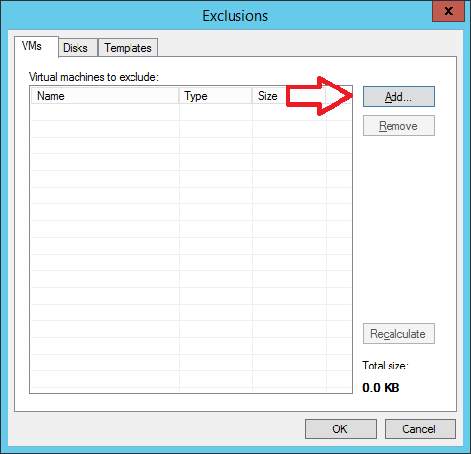

* + Again, click the third icon and browse to the backup server/the folder(s) to exclude:

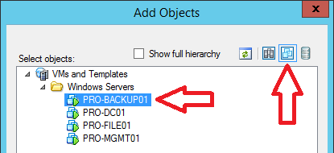

* + Click 'Add'
  + And click 'OK'

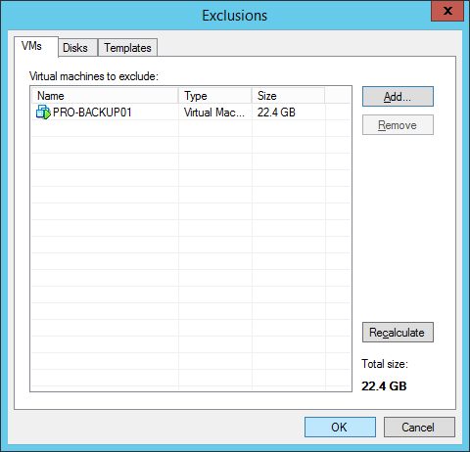

* + The exclusion has been added…
* In 'Virtual Machines' window, click 'Next'
* In the 'Storage Window', select following parameters but **do not press 'next' yet!**
  + Backup Proxy: 'Choose' the VMWare Backup Proxy. (Not automatic!)
  + Backup Repository: Synology
  + Retention Policy: 21 Restore Points
  + Keep 'Secondary locations' unchecked.

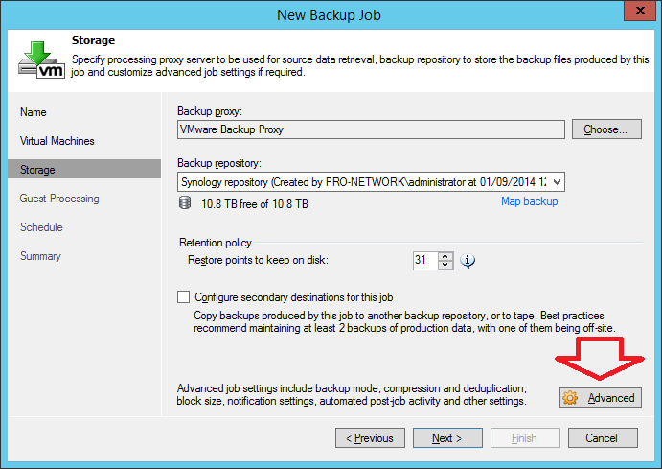

* Click 'Advanced'
* On the tab 'Backup'
  + Select 'Incremental'
    - Leave 'Create synthetic full backups periodically' checked
    - Click 'Days' and select Saturday for windows and Sunday for Linux & others.
  + Check 'Perform active full backups periodically'
  + Select Monthly (and select all months)
    - First Monday for Windows Server Backups
    - Second Monday for Windows Client backups
    - Third Monday for Linux Server backups
    - Fourth Monday for Other backups

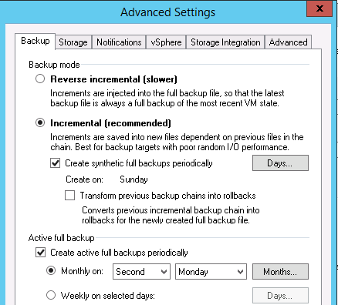

* Tab Storage
  + Leave everything default except 'Storage optimization': LAN target
* Tab Notifications
  + Set successful backup details to the VM attribute: Backup
  + Uncheck "append"

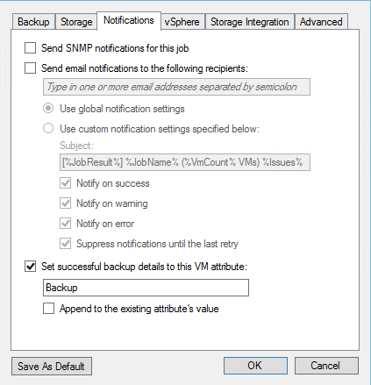

* Tab vSphere 🡪 keep default
* Tab Storage Integration 🡪 keep default
* Tab Advanced
  + Leave Checked 'Enable automatic integrity checks'
  + Check 'Remove deleted VMs data from backup' and set it to 14 days.
  + Leave unchecked 'Run the following command'

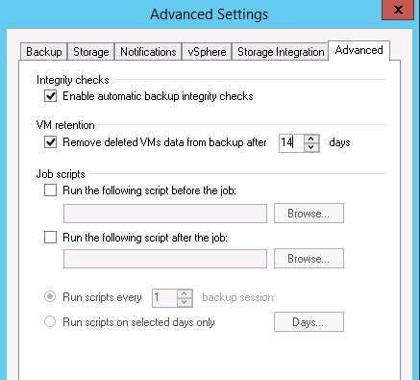

* Click OK to return to the 'Storage' window
* In the 'storage' Window, Click 'Next'

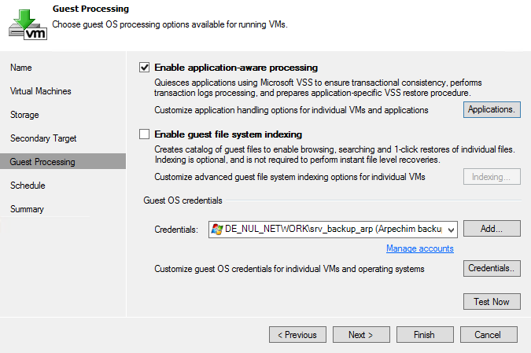

* In the 'Guest processing' windows
  + For Windows backups:
    - Select **Enable** application aware processing'
    - Select **Disable** guest file system indexing'
    - Credential select the domain srv_backup user
    - Click "Applications" to access advanced settings:
      * Select the folder and click "edit"
      * Under "General" > "Applications", select "try application processing, but ignore failures" to allow it to attempt using VSS, but still continue to take backups the normal way if it fails.
      * 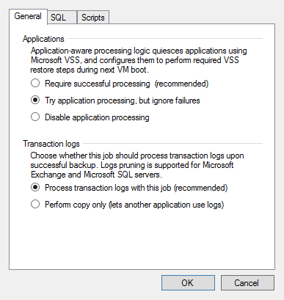
  + Linux Servers and "Others" backups:
    - Select **Disable** application aware image processing'
    - Select **Disable** guest file system indexing'
* Click "Next"
* In the schedule window, select the backup schedule
  + Select "Run the job automatically"
  + Schedule:

Windows Server Backups: daily at 22:00 UTC

Windows Client Backups: daily at 04:00 UTC

Other Server Backups: daily at 10:00 UTC

Linux Server Backups: daily at 16:00 UTC

* + Leave Automatic retry default
  + Leave Backup Window options default

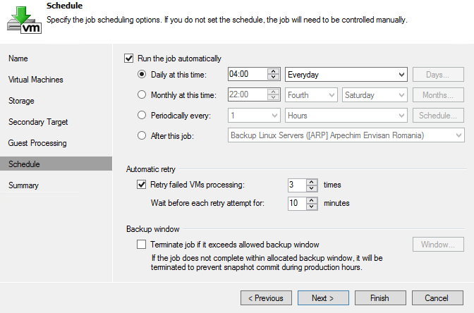

* Click 'Finish'…

**REPEAT THIS PROCEDURE FOR ALL SCHEDULES…**